KONFIGURASI REPLIKASI MASTER & SLAVE MARIADB PADA VPS CENTOS7
1. Persiapan
Master | Slave
OS: Centos7 | OS: Centos7
IP: 117.53.44.123 | IP: 117.53.45.266
MariaDB 10. | MariaDB 10.

2. Install tambahkan repo mariadb
vim /etc/yum.repos.d/mariadb.repo
…………
[mariadb]
name = MariaDB
baseurl = http://yum.mariadb.org/10.1/centos7-amd64
gpgkey=https://yum.mariadb.org/RPM-GPG-KEY-MariaDB
gpgcheck=1
……………
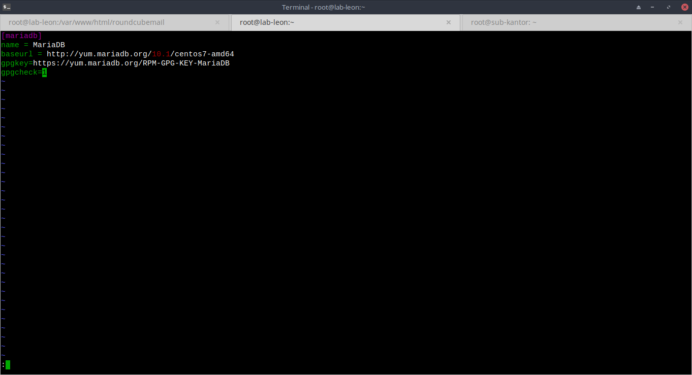
3. install mariadb-server pada kedua VM
yum -y install mariadb-server
systemctl start mariadb
systemctl enable mariadb
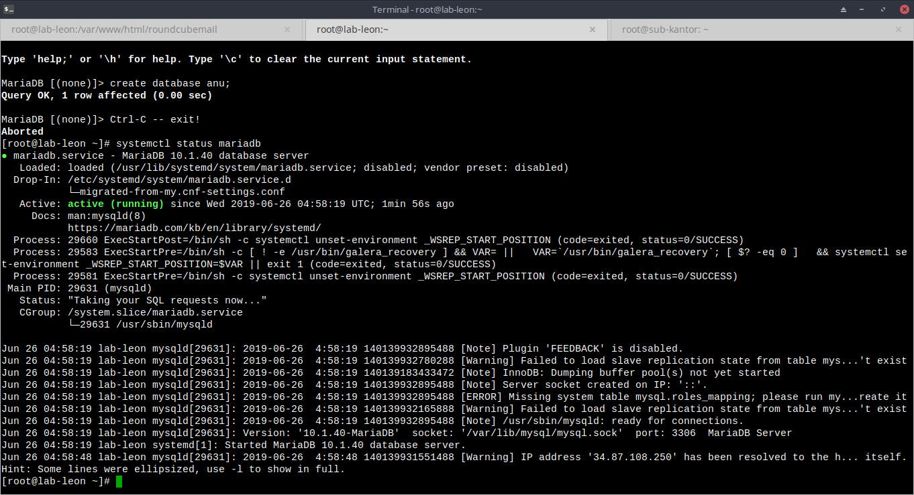
4. pada master buat user baru untuk slave
GRANT REPLICATION SLAVE ON *.* TO 's'@'%' IDENTIFIED BY 's';

5. Pada master modif file my.conf
vim /etc/my.cnf
..........
[mysqld]
datadir=/var/lib/mysql
socket=/var/lib/mysql/mysql.sock
symbolic-links=0
server-id = 1
expire_logs_days = 14
log_bin
log-basename=master
binlog-ignore-db = information_schema
binlog-ignore-db = mysql
binlog-ignore-db = performance_schema
binlog-ignore-db = test
symbolic-links=0

[mysqld_safe]
log-error=/var/log/mariadb/mariadb.log
pid-file=/var/run/mariadb/mariadb.pid
..............…
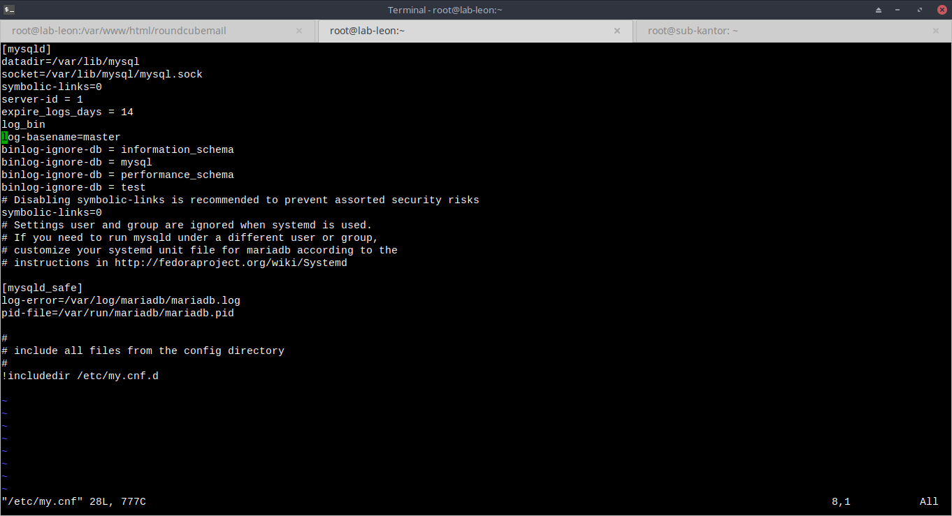
6. Restart service mariadb
systemctl restart mariadb

7. Flush table pada master
FLUSH TABLES WITH READ LOCK;
SHOW MASTER STATUS;
#JANGAN KELUAR DRI MYSQL KARNA AKAN MERUSAK LOCK TABLE
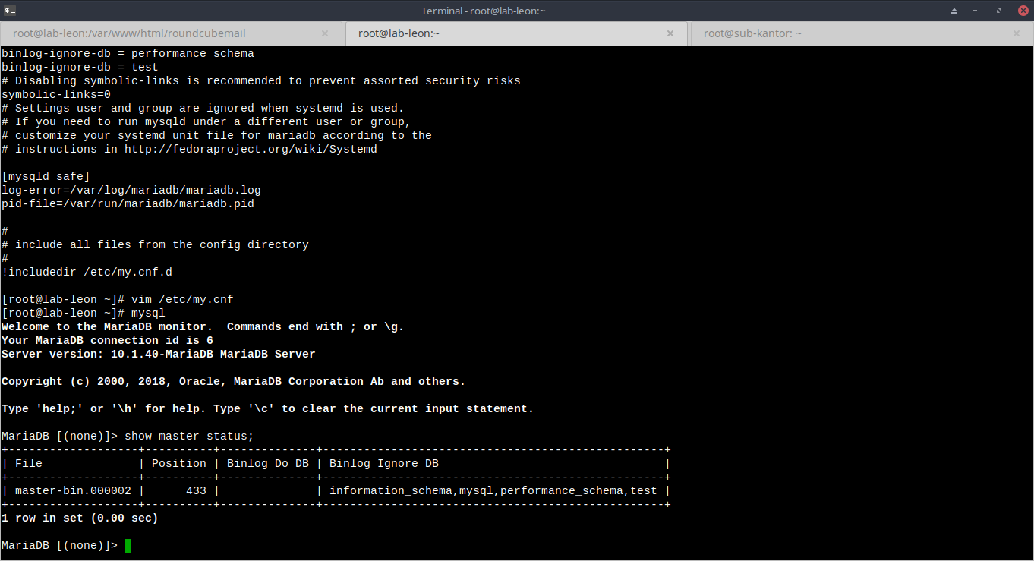
8. Dump database pada master dan copy ke slave
mysqldump --all-database -u root -p > master.sql
scp master.sql root@117.53.45.266:/root

9. Pada Slave modif konfigurasi my.cnf
vim /etc/my.cnf
……….
[mysqld]
datadir=/var/lib/mysql
socket=/var/lib/mysql/mysql.sock
symbolic-links=0
server-id = 2
[mysqld_safe]
log-error=/var/log/mariadb/mariadb.log
pid-file=/var/run/mariadb/mariadb.pid
………..
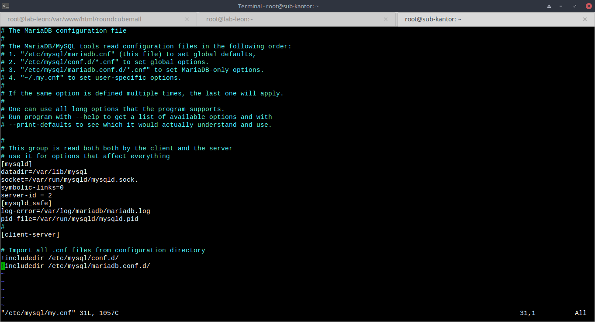
10. Load dump master
mysql -u root -p < master.sql

11. stop slave dan daftarkan master pada slave
SLAVE STOP;
CHANGE MASTER TO MASTER_HOST='117.53.44.123', MASTER_USER='s', MASTER_PASSWORD='s', MASTER_LOG_FILE='master-bin.000002', MASTER_LOG_POS=443;
START SLAVE;

